**Databases and SQL**

**Data Manipulation Language:**

*SELECT, INSERT, UPDATE, DELETE*

**Data Definition Language:**

*CREATE, ALTER, DROP, TRUNCATE*

**Data Control Language**

*GRANT, REVOKE*

**Transaction Control Language**

*COMMIT, ROLLBACK, SAVEPOINT*

**COMMON DATATYPES**

VARCHAR(x) – alphanumeric data up to x characters long

CHAR(x) - alphanumeric data exactly x characters long, padded with whitespaces

DATE – stores date and time, can be manipulated using FORMAT() or CONVERT() to be more human readable or to remove irrelevant data

DECIMAL(x,y) – stores a decimal of x total digits, y digits after the decimal point

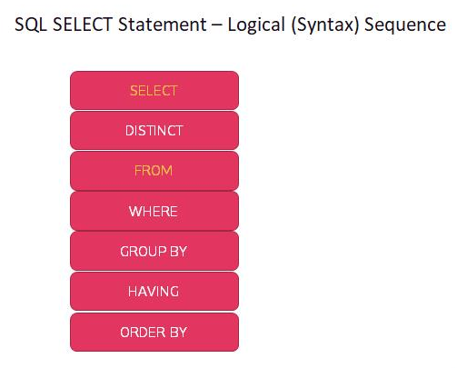**Processing sequence**

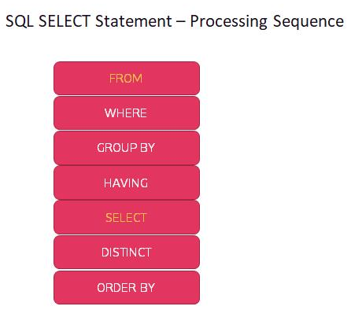

**NORMALISATION**

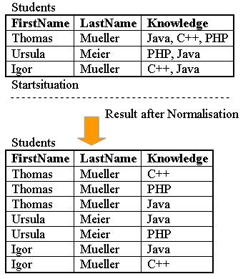

**First Normal Form (1NF)**

* Data is atomic, i.e. as small as possible
* No repeating groups

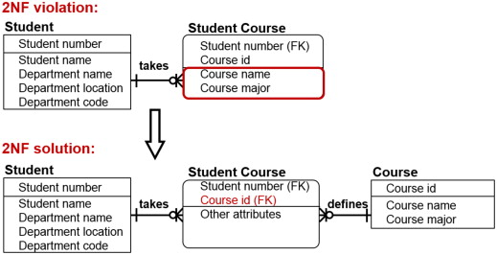**Second Normal Form (2NF)**

* Be in first normal form
* every non key attribute is fully functionally dependent on the primary key
* In 2NF primary keys are often composite

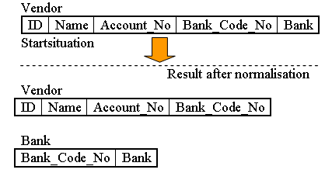**Third Normal Form (3NF)**

* Be in second normal form
* No transitive functional dependencies
* "every non-key attribute must provide a fact about the key, the whole key, and nothing but the key so help me Codd"
* Many composite keys created from 2NF normalisation are changed here if an attribute is not dependant on all the composite attributes

**WILDCARDS**

* * selects all info
* % used in a like statement allows any number of any character
* _ allows one character

Joins

